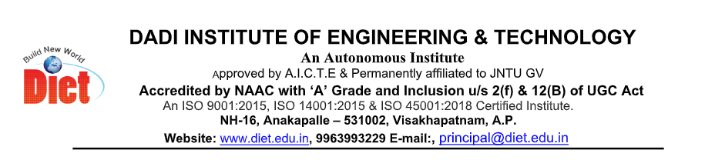

STUDENT ACHIEVEMENTS
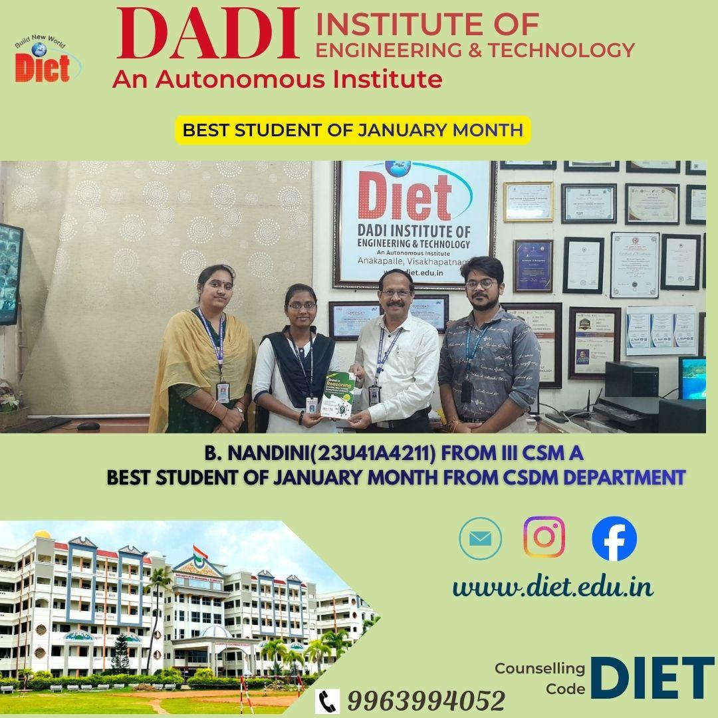

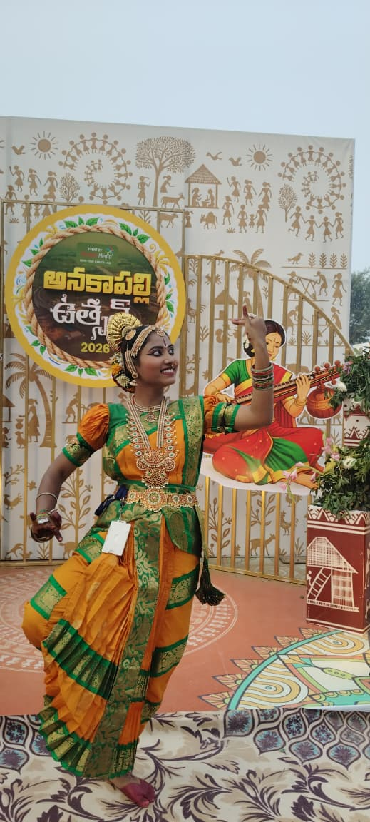

B.NANDHINI FROM III CSM A PERFORMED CLASSICAL DANCE AT ANAKAPALLI UTSAV 2026

FACULTY ACHIEVEMENTS

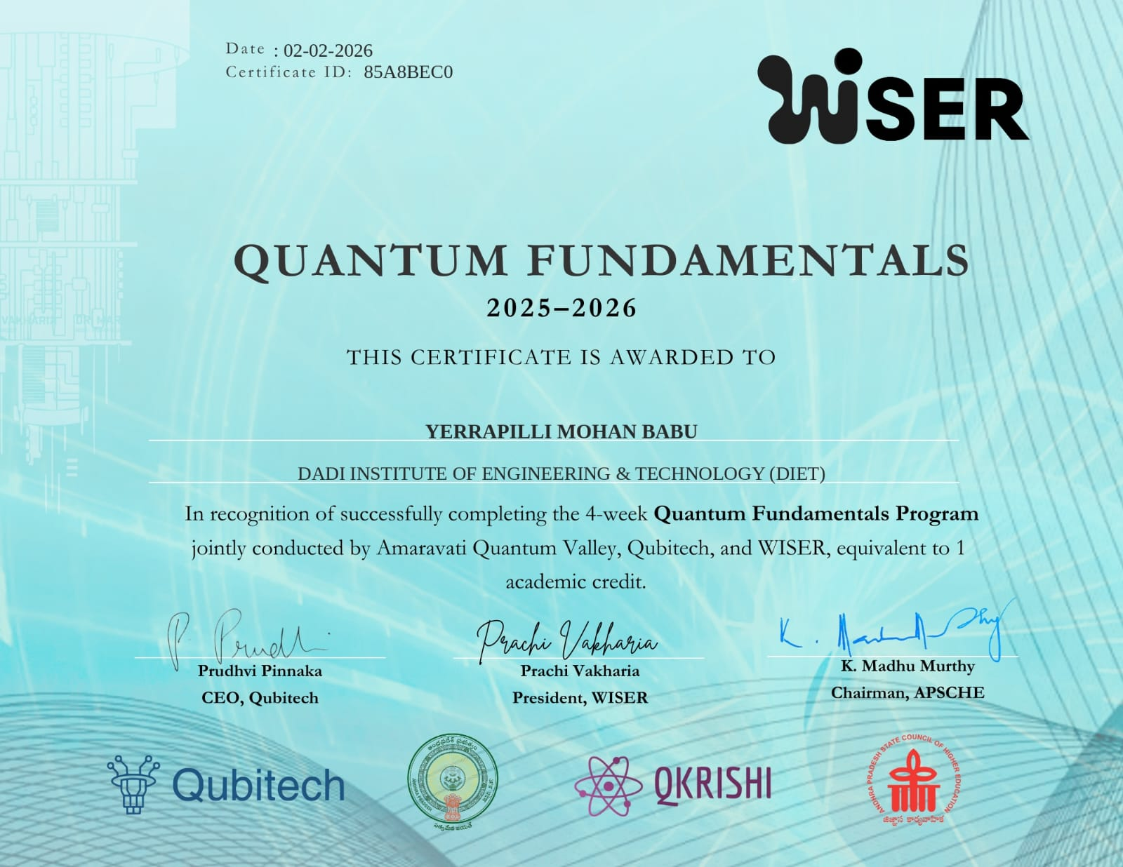

Y.MOHANBABU
QUANTUM FUNDAMENTALS PROGRAM OF 4 WEEKS COMPLETED

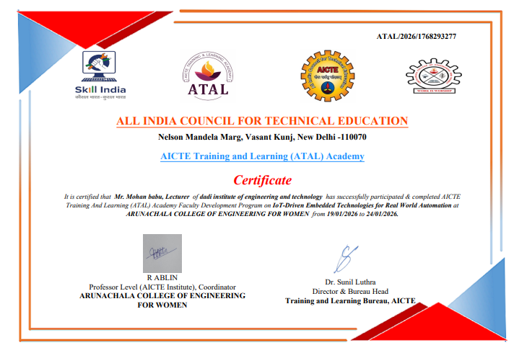
Mr. Mohan babu, Lecturer of dadi institute of engineering and technology has successfully participated & completed AICTE Training And Learning (ATAL) Academy Faculty Development Program on IoT-Driven Embedded Technologies for Real World Automation

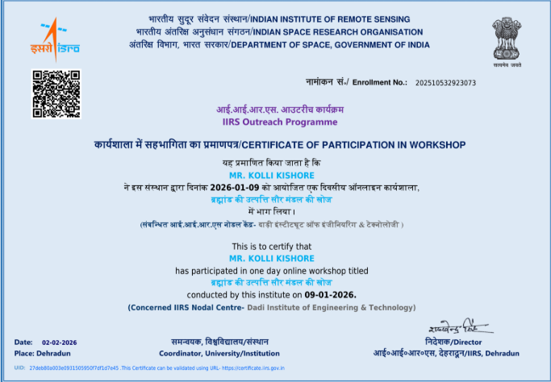
MR. KOLLI KISHORE has participated in a one-day online workshop conducted by this institute on 09-01-2026. (Concerned IIRS Nodal Centre –ISRO INDIA)

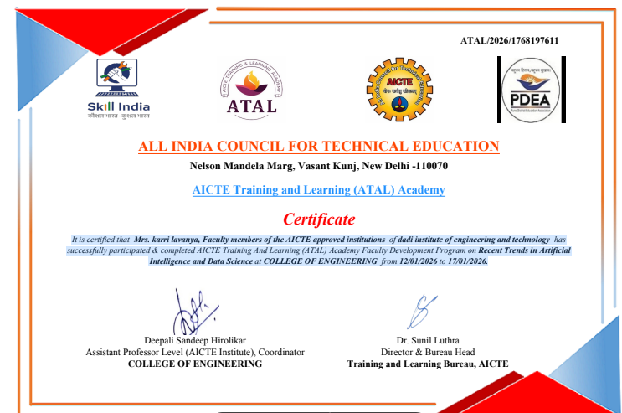
It is certified that Mrs. karri lavanya, Faculty members of the AICTE approved institutions of dadi institute of engineering and technology has
successfully participated & completed AICTE Training And Learning (ATAL) Academy Faculty Development Program on Recent Trends in Artificial
Intelligence and Data Science at COLLEGE OF ENGINEERING from 12/01/2026 to 17/01/2026.

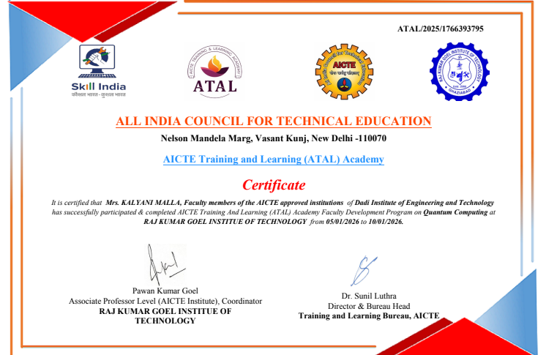

It is certified that Mrs. KALYANI MALLA, Faculty members of the AICTE approved institutions of Dadi Institute of Engineering and Technology
has successfully participated & completed AICTE Training And Learning (ATAL) Academy Faculty Development Program on Quantum Computing at
RAJ KUMAR GOEL INSTITUTE OF TECHNOLOGY from 05/01/2026 to 10/01/2026.

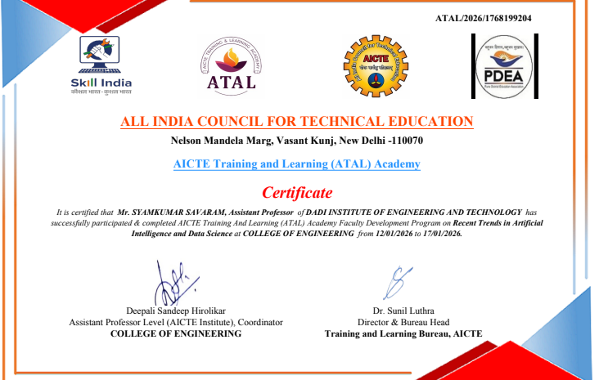
It is certified that Mr. SYAMKUMAR SAVARAM, Assistant Professor of DADI INSTITUTE OF ENGINEERING AND TECHNOLOGY has
successfully participated & completed AICTE Training And Learning (ATAL) Academy Faculty Development Program on Recent Trends in Artificial
Intelligence and Data Science at COLLEGE OF ENGINEERING from 12/01/2026 to 17/01/2026.

