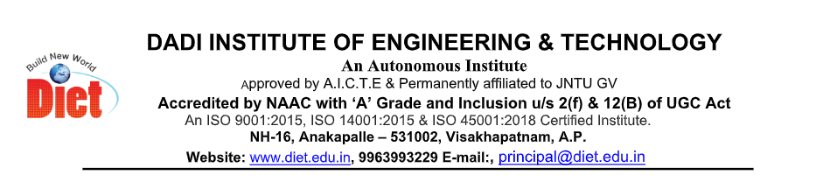

DIET IEEE STUDENT BRANCH
Inaugural Of DIET IEEE CS Chapter
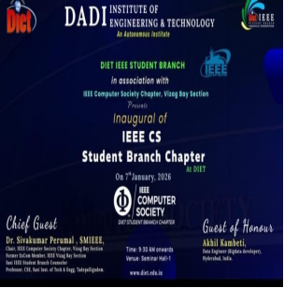
DIET IEEE Student Branch successfully organized the IEEE Computer Society Student Branch Chapter Inauguration Ceremony, marking a significant milestone in strengthening technical excellence and professional engagement among students. The inauguration of the Computer Society Chapter aims to provide students with a global platform for learning, innovation, research, and industry interaction in the domain of computing technologies. IEEE Computer Society, being one of the world’s leading professional organizations, plays a vital role in promoting knowledge sharing, research activities, and professional development.

Welcome Address

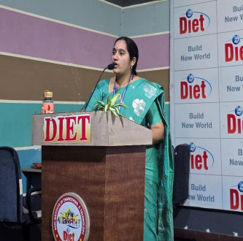

Dr. A. S. L. K. Gopalamma
( HOD OF CSDM DEPARTMENT)
Advisor, DIET IEEE Computer Society Student Branch, delivered the welcome address and extended a warm greeting to all the dignitaries, faculty members, and students present for the inauguration ceremony. In her address, she highlighted the pivotal role of IEEE in shaping students’ professional growth by providing access to globally recognized technical resources and learning platforms. She emphasized that the IEEE Computer Society enables students to gain international exposure, enhance their technical competency, and develop essential leadership and professional skills. She also encouraged students to actively participate in IEEE activities and make effective use of the opportunities offered to build strong and successful careers in the field of computing technologies.



Dr. R. Vaikunta Rao
(PRINCIPAL,DIET)
Principal, addressed the gathering and highlighted the significant role of professional organizations such as IEEE in effectively bridging the gap between academic learning and industry requirements. In his address, he emphasized that participation in IEEE activities equips students with practical exposure, contemporary technical knowledge, and professional skills essential for today’s competitive environment. He encouraged students to actively involve themselves in IEEE initiatives, technical events, workshops, conferences, and research activities, stating that such engagement would greatly enhance their technical competence, innovation capabilities, and overall career prospects. He further stressed the importance of continuous learning and adaptability in the rapidly evolving technological landscape, advising students to make effective use of IEEE platforms for skill enhancement and professional networking. He concluded his address by reaffirming the institution’s commitment to supporting IEEE activities and encouraging students to uphold professional ethics while striving for excellence in their academic and professional endeavours.
Technical Session
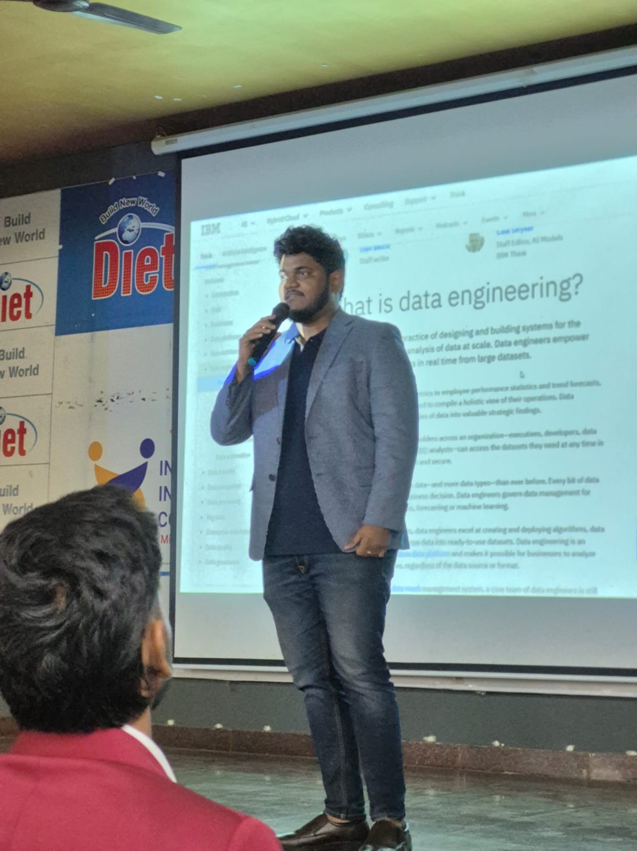
A detailed Technical Session was conducted by Sri Akhil Kambeti, focusing on:

- Big Data and Data Engineering
- Industry tools and technologies
- Career opportunities in computing domains
- Practical insights into industry workflows

The session was interactive and highly beneficial to students. All the distinguished dignitaries were felicitated as a mark of respect and appreciation for their valuable presence and meaningful contributions to the inauguration ceremony. The organizing committee expressed sincere gratitude for their guidance, encouragement, and continued support, acknowledging their role in inspiring students and strengthening the objectives of the IEEE Computer Society Student Branch Chapter. Additionally, the session offered practical insights into industry workflows, enabling students to understand real-world project execution and professional practices. The session was highly interactive, with active participation from students, and proved to be extremely beneficial in enhancing their technical understanding and career awareness

Interactive Session

An engaging Interactive Session with Dr. P. Siva Kumar provided students with an opportunity to clarify their queries related to IEEE memberships, research publications, professional growth opportunities, and leadership roles within IEEE. The session encouraged open discussion and active participation, enabling students to gain valuable guidance on effectively utilizing IEEE platforms for academic advancement, research contributions, and professional development.

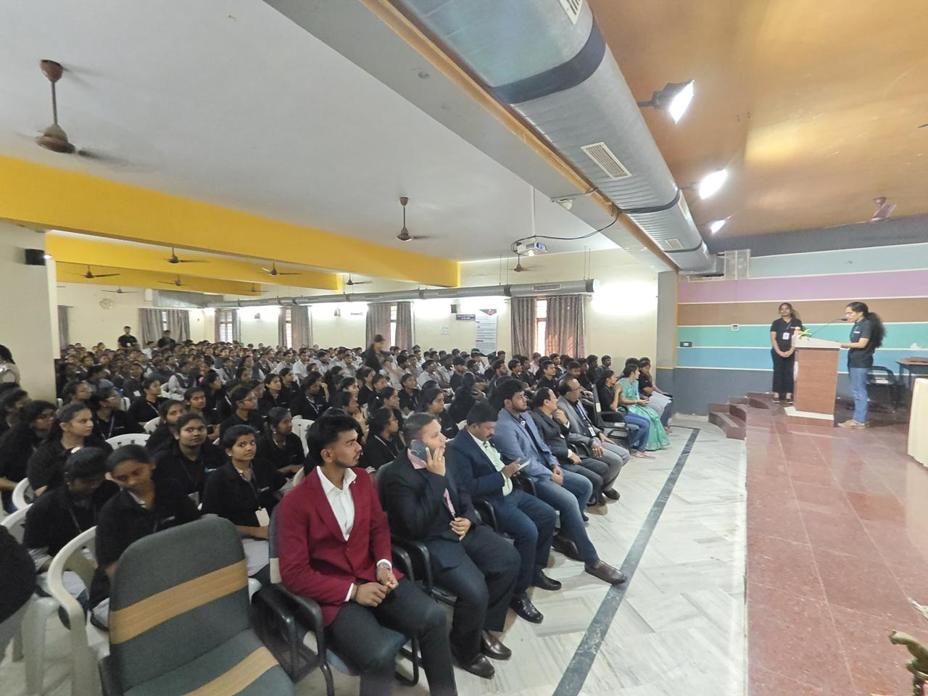

STUDENT INTERACTION

