DIET IEEE STUDENT BRANCH
Inaugural Of DIET IEEE CS Chapter
Organized by : DIET IEEE SB Date : 7th January 2026
Venue : DIET Seminar Hall – 1 (AC)
Time : 09:20 AM – 12:25 PM
Mode : Offline Introduction
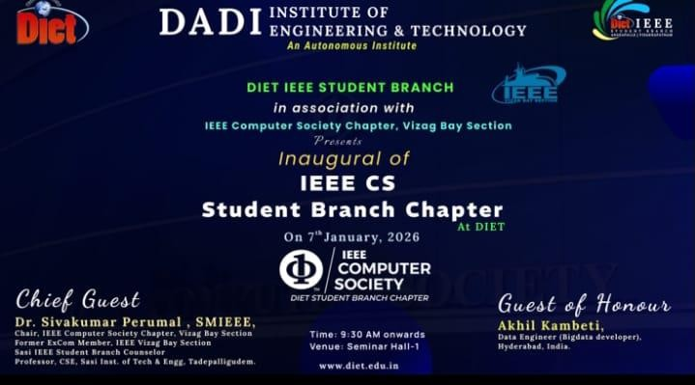
DIET IEEE Student Branch successfully organized the IEEE Computer Society Student Branch Chapter Inauguration Ceremony, marking a significant milestone in strengthening technical excellence and professional engagement among students. The inauguration of the Computer Society Chapter aims to provide students with a global platform for learning, innovation, research, and industry interaction in the domain of computing
technologies. IEEE Computer Society, being one of the world’s leading professional organizations, plays a vital role in promoting knowledge sharing, research activities, and professional development. The establishment of this chapter reflects DIET’s commitment to fostering a strong technical and research-oriented culture. The inauguration of the Computer Society Chapter aims to provide students with extensive opportunities for innovation, research, and meaningful industry interaction in the rapidly evolving domain of computing technologies, thereby bridging the gap between academic learning and professional practice. DIET IEEE Student Branch successfully organized the IEEE Computer Society SB Chapter Inauguration Ceremony, marking a
significant milestone in strengthening technical excellence and professional engagement among students by creating a structured and globally connected platform for learning and growth. The inauguration of the Computer Society Chapter aims to provide students with extensive opportunities for innovation, research, and meaningful industry interaction in the rapidly evolving domain of computing technologies, thereby bridging the gap between academic learning and professional practice. As one of the world’s leading professional organizations, the IEEE Computer Society plays a vital role in promoting knowledge sharing, research activities, and professional development across academia and industry. The establishment of this chapter reflects DIET’s strong commitment to fostering a technically robust, research-oriented culture that encourages students to develop critical thinking, leadership skills, and global competence essential for successful engineering careers.

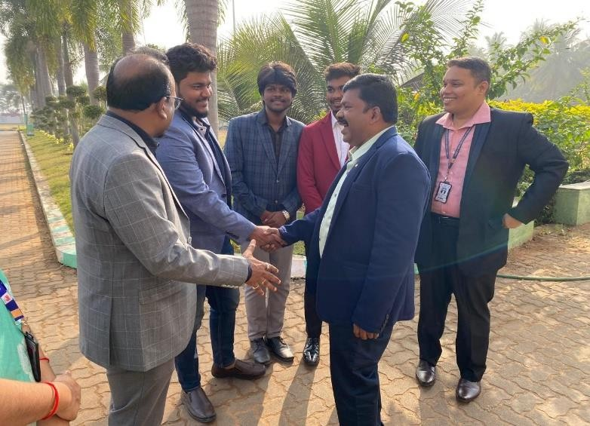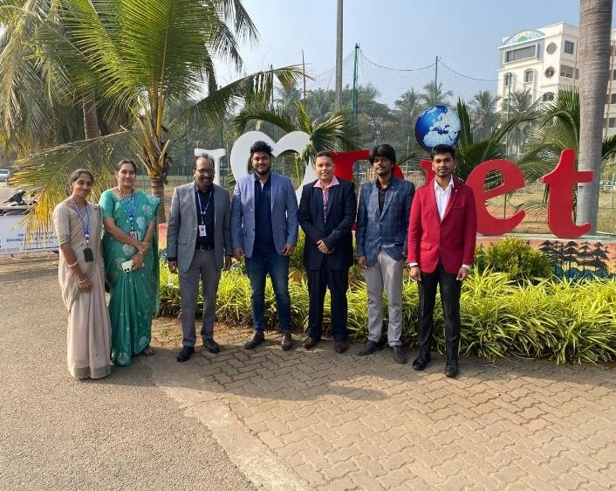
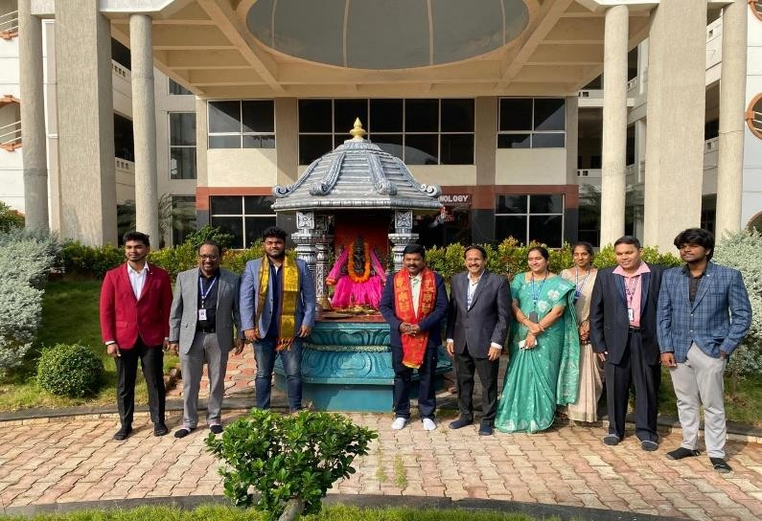
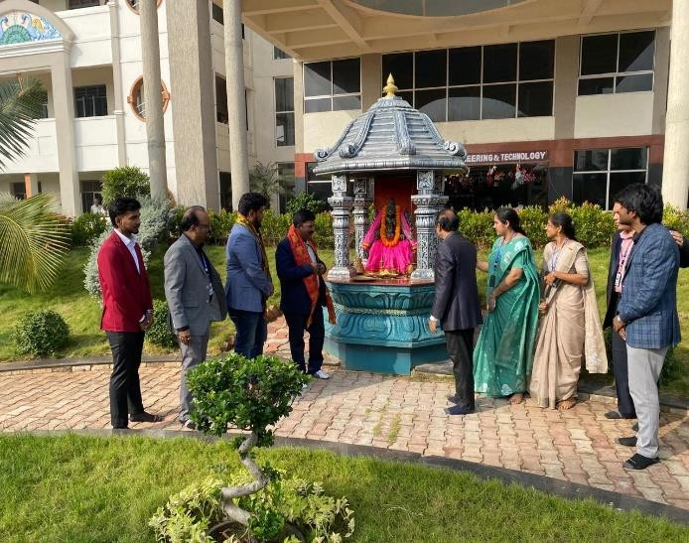
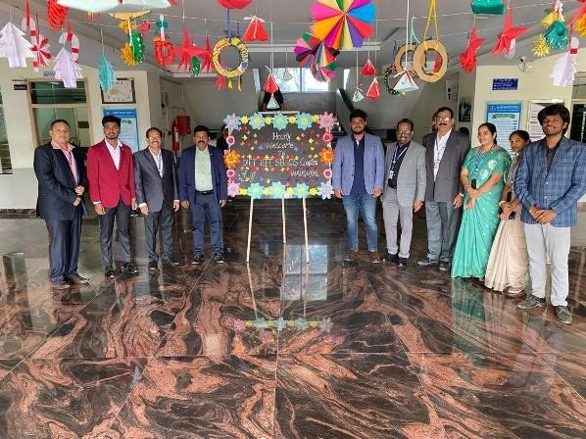
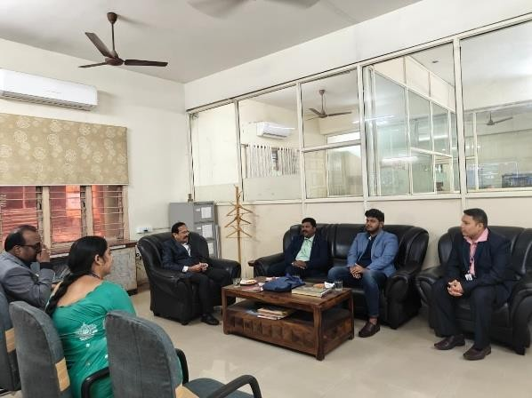

Objectives of the Event
The primary objectives of the IEEE Computer Society Student Branch Chapter Inauguration Ceremony were to formally establish the Computer Society Chapter at DIET and mark the beginning of focused computing-related professional activities under the IEEE framework. The event aimed to create comprehensive awareness among students about the IEEE Computer Society, its global presence, and the wide range of academic, technical, and professional benefits it offers, including access to conferences, journals, workshops, and international networking opportunities.
The primary objectives of the inauguration ceremony were:
- To formally establish the IEEE Computer Society Student Branch Chapter at DIET.
- To create awareness about IEEE Computer Society and its benefits.
- To motivate students towards research, publications, and technical innovation.
- To provide industry exposure and professional guidance.
- To encourage active student participation in IEEE activities.
Another key objective was to motivate students to actively engage in research-oriented activities, technical innovation, and scholarly publications by encouraging them to explore emerging technologies and contribute to knowledge creation. The ceremony also sought to provide students with valuable industry exposure and professional guidance through interactions with experienced academicians and industry experts, helping them understand real-world expectations and career pathways. Furthermore, the event aimed to inspire students to actively participate in IEEE activities, develop leadership and teamwork skills, and become responsible contributors to the professional and technical community at both national and international levels.
In addition to the stated objectives, the inauguration ceremony was designed to serve as a catalyst for building a strong and sustainable computing-focused community within the institution. The event aimed to lay a structured foundation for future IEEE Computer Society activities such as technical workshops, seminars, hackathons, expert talks, and collaborative research programs. By introducing students to the organizational framework and professional ethics of IEEE, the ceremony sought to instill a sense of responsibility, discipline, and commitment toward continuous learning and professional excellence. Moreover, the event emphasized the importance of peer learning, interdisciplinary collaboration, and global engagement, enabling students to broaden their perspectives and prepare themselves to meet the evolving challenges of the technology-driven world while actively contributing to the advancement of the computing profession. the inauguration ceremony aimed to align students with global technological advancements by encouraging them to adopt a forward-looking and innovation-driven approach to learning.
The event was intended to promote a culture of continuous skill enhancement, critical thinking, and problem-solving by exposing students to IEEE’s international standards and best practices in computing disciplines. By fostering collaboration between students, faculty, and industry professionals, the ceremony sought to create an environment that supports mentorship, knowledge exchange, and professional networking. This initiative was envisioned to empower students to take initiative in organizing and participating in IEEE Computer Society activities, thereby enhancing their technical competence, professional confidence, and readiness to contribute meaningfully to the global engineering community.

Program Proceedings
The program commenced with the formal gathering of participants, including faculty members, IEEE student volunteers, and enthusiastic student attendees, creating an academically vibrant atmosphere. This was followed by a detailed presentation highlighting the activities, achievements, and milestones of the DIET IEEE Student Branch, providing an overview of its contributions to technical learning and professional development. Subsequently, the distinguished dignitaries were respectfully invited onto the dais, after which the event was ceremonially inaugurated with the traditional lighting of the lamp. The lamp-lighting ceremony symbolized the dispelling of ignorance through knowledge and marked the beginning of a new phase of learning, enlightenment, and technological advancement under the IEEE Computer Society Student Branch Chapter.
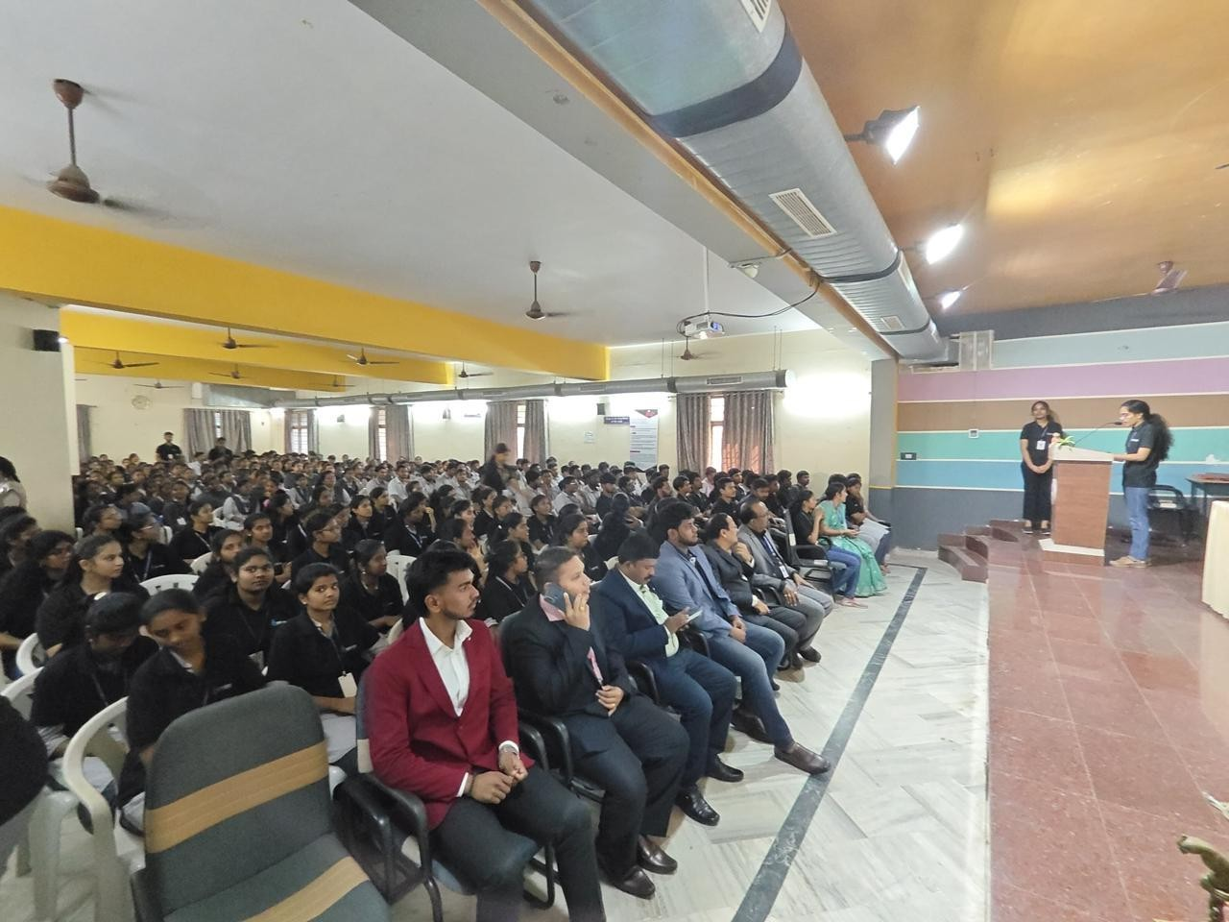

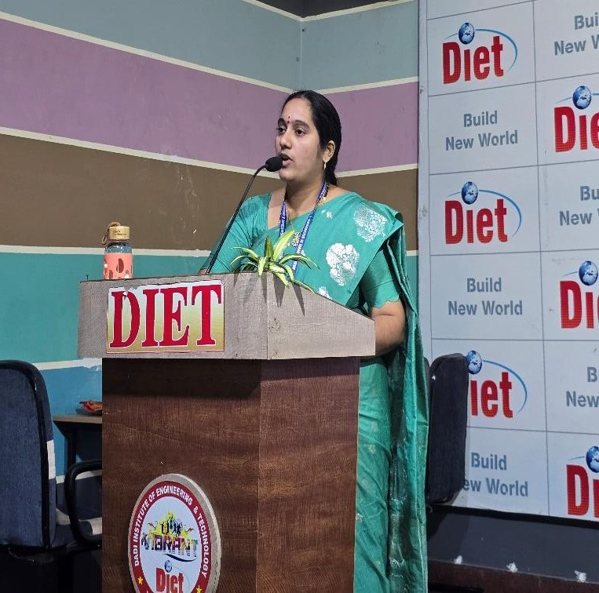
Welcome Address

Dr. A. S. L. K. Gopalamma,
Advisor, DIET IEEE Computer Society Student Branch, delivered the welcome address and extended a warm greeting to all the dignitaries, faculty members, and students present for the inauguration ceremony. In her address, she highlighted the pivotal role of IEEE in shaping students’ professional growth by providing access to globally recognized technical resources and learning platforms. She emphasized that the IEEE Computer Society enables students to gain international exposure, enhance their technical competency, and develop essential leadership and professional skills. She also encouraged students to actively participate in IEEE activities and make effective use of the opportunities offered to build strong and successful careers in the field of computing technologies.

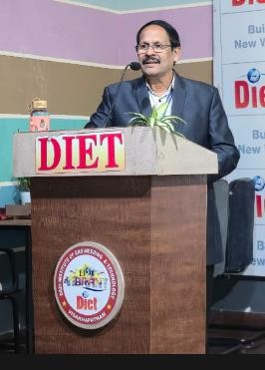
Address by the Principal

Dr. R. Vaikunta Rao,
Principal, addressed the gathering and highlighted the significant role of professional organizations such as IEEE in effectively bridging the gap between academic learning and industry requirements. In his address, he emphasized that participation in IEEE activities equips students with practical exposure, contemporary technical knowledge, and professional skills essential for today’s competitive environment. He encouraged students to actively involve themselves in IEEE initiatives, technical events, workshops, conferences, and research activities, stating that such engagement would greatly enhance their technical competence, innovation capabilities, and overall career prospects. He further stressed the importance of continuous learning and adaptability in the rapidly evolving technological landscape, advising students to make effective use of IEEE platforms for skill enhancement and professional
networking. He concluded his address by reaffirming the institution’s commitment to supporting IEEE activities and encouraging students to uphold professional ethics while striving for excellence in their academic and professional endeavours.

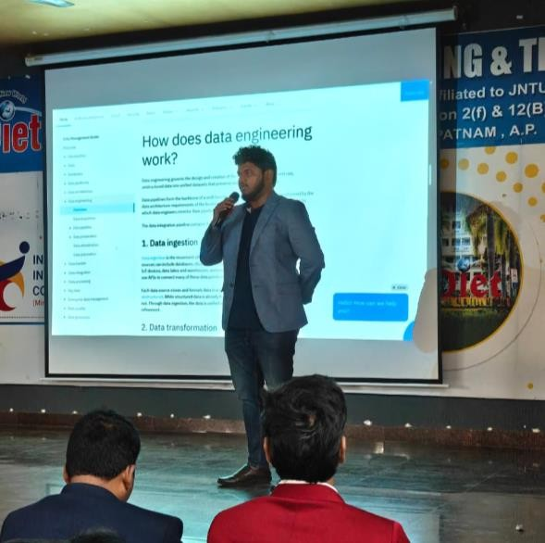
Guest of Honor Session
The Guest of Honor, Sri Akhil Kambeti, Data Engineer (Big Data Developer), IBM India Pvt. Ltd., addressed the students and shared valuable insights on emerging technologies, evolving industry expectations, and the importance of continuous learning in the field of computing. During his session, he emphasized the need for students to develop strong foundational knowledge along with practical skills to remain relevant in the competitive technology landscape. He highlighted real- world industry practices, career pathways, and the significance of adapting to technological advancements, motivating students to effectively align their academic learning with real-world industry requirements and professional standards.

Chief Guest Address
Dr. P. Siva Kumar,

Chair, IEEE Computer Society Chapter, Vizag Bay Section, delivered an enlightening address highlighting the mission, vision, and global impact of the IEEE
Computer Society in advancing computing knowledge and professional excellence. In his address, he emphasized the importance of active student involvement in IEEE initiatives and encouraged students to make effective use of IEEE resources such as international conferences, reputed journals, technical workshops, and professional networking platforms. He also motivated students to contribute to research, innovation, and community-driven technical activities, stating that engagement with IEEE would significantly enhance their professional growth, global exposure, and career development. He further highlighted the value of IEEE membership in building a strong professional identity and staying updated with emerging technologies and global standards. He concluded his address by inspiring students to take leadership roles within IEEE Computer Society activities and
actively contribute to the advancement of the computing profession at both national and international levels. He also emphasized the importance of collaboration, ethical responsibility, and lifelong learning as key pillars for success in the computing profession. The address concluded with a call for students to leverage the IEEE Computer Society platform to become innovators and change-makers capable of addressing real-world technological challenges.

Official Launch of CS Chapter
A major highlight of the event was the official launch of the DIET IEEE Computer Society Student Branch Chapter, marking the beginning of a new era of computing-focused academic and professional activities at DIET. The launch symbolized the institution’s commitment to advancing technical knowledge, research culture, and professional development in the field of computing. As part of the ceremony, the IC-PINAKA 2026 Conference Brochure was formally released, signifying DIET’s active involvement in promoting research dissemination and academic collaboration through IEEE-supported conferences and technical forums.
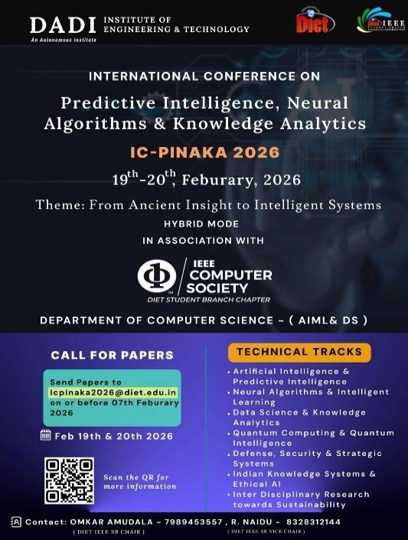
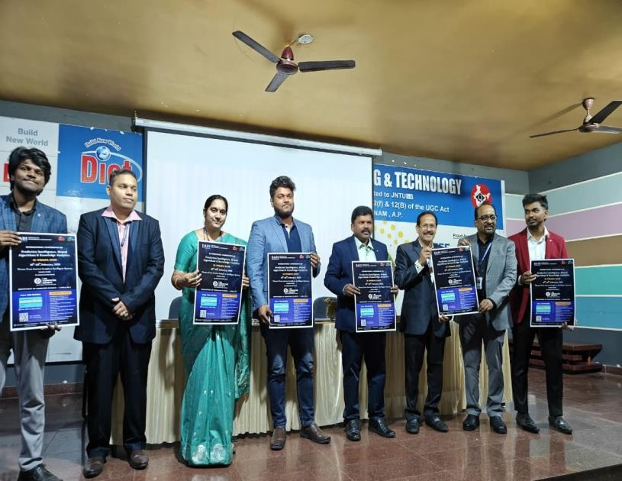
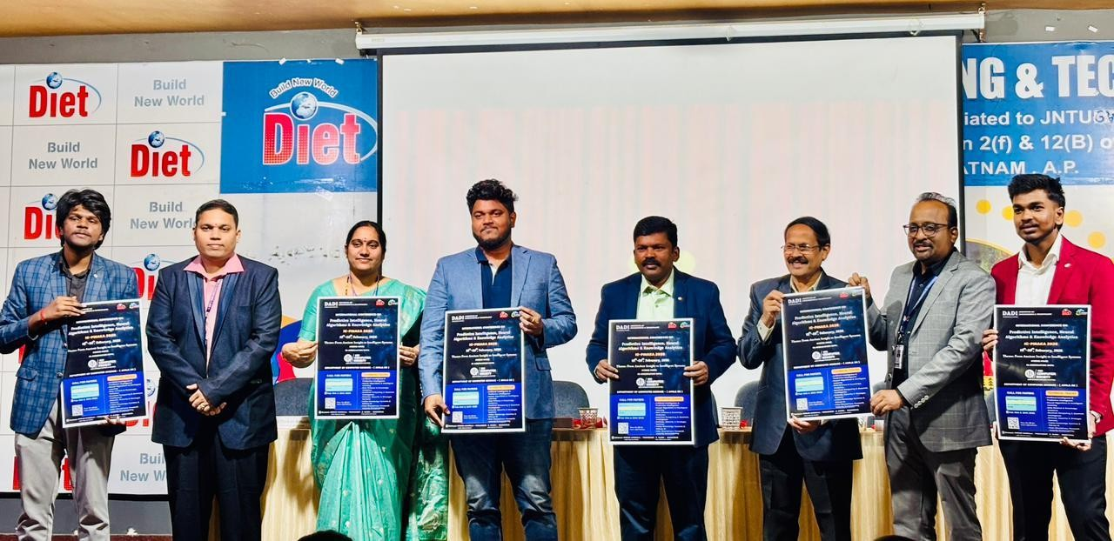

Felicitation Ceremony
All the distinguished dignitaries were felicitated as a mark of respect and appreciation for their valuable presence and meaningful contributions to the inauguration ceremony. The organizing committee expressed sincere gratitude for their guidance, encouragement, and continued support, acknowledging their role in inspiring students and strengthening the objectives of the IEEE Computer Society Student Branch Chapter.
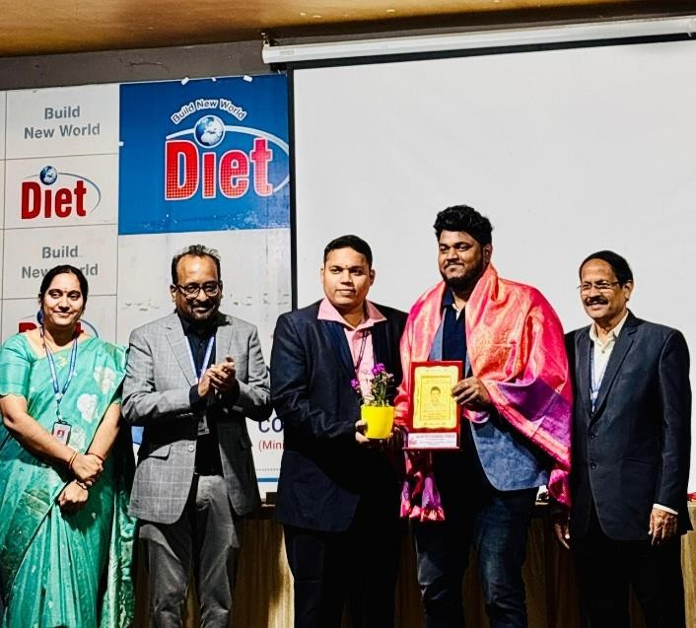
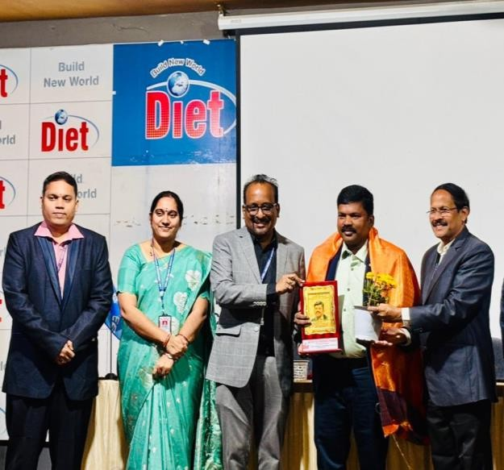

Technical Session
A detailed Technical Session was conducted by Sri Akhil Kambeti, focusing on:
- Big Data and Data Engineering
- Industry tools and technologies
- Career opportunities in computing domains
- Practical insights into industry workflows
The session was interactive and highly beneficial to students. All the distinguished dignitaries were felicitated as a mark of respect and appreciation for their valuable presence and meaningful contributions to the inauguration ceremony. The organizing committee expressed sincere gratitude for their guidance, encouragement, and continued support, acknowledging their role in inspiring students and strengthening the objectives of the IEEE Computer Society Student Branch Chapter. Additionally, the session offered practical insights into industry workflows, enabling students to understand real-world project execution and professional practices. The session was highly interactive, with active participation from students, and proved to be extremely beneficial in enhancing their technical understanding and career awareness.

Interactive Session
An engaging Interactive Session with Dr. P. Siva Kumar provided students with an opportunity to clarify their queries related to IEEE memberships, research publications, professional growth opportunities, and leadership roles within IEEE. The session encouraged open discussion and active participation, enabling students to gain valuable guidance on effectively utilizing IEEE platforms for academic advancement, research contributions, and professional development.


Vote of Thanks
The event concluded with a formal Vote of Thanks proposed by Mr. A. Krishna Nag, Chair, DIET IEEE Student Branch. In his address, he expressed sincere gratitude to the management for their constant support, the faculty members for their guidance, the distinguished guests for sharing their valuable insights, and the IEEE volunteers and students for their dedicated efforts. He acknowledged the collective contribution of all stakeholders in making the IEEE Computer Society Student Branch Chapter Inauguration Ceremony a grand success.

Outcome of the Event
The IEEE Computer Society Student Branch Chapter Inauguration Ceremony resulted in increased awareness among students about the role and benefits of the IEEE Computer Society. The event significantly enhanced student motivation toward research, innovation, and advanced technical learning by exposing them to global professional standards and opportunities. It also strengthened industry–academia interaction through expert addresses and technical discussions, providing students with valuable insights into real-world expectations. Furthermore, the ceremony encouraged active student participation in IEEE activities, fostering leadership skills, professional engagement, and a sustained interest in technical and research-oriented initiatives.
In addition, the ceremony encouraged active student participation in IEEE activities, promoting leadership, teamwork, and professional ethics. The event contributed to improved understanding of career pathways in computing domains, fostered a culture of continuous learning, and laid the groundwork for future IEEE Computer Society programs such as workshops, seminars, hackathons, and research collaborations.

Conclusion
The IEEE Computer Society Student Branch Chapter Inauguration at DIET proved to be a meaningful and impactful event, marking the successful establishment of a dedicated platform for computing-focused professional and technical activities. The ceremony laid a strong foundation for future initiatives such as technical workshops, research programs, seminars, conferences, and industry interactions under the IEEE Computer Society framework. The DIET IEEE Student Branch remains committed to empowering students by providing access to globally recognized professional platforms, fostering technical excellence, research orientation, and leadership development, thereby preparing students to meet the evolving challenges of the global technology landscape.

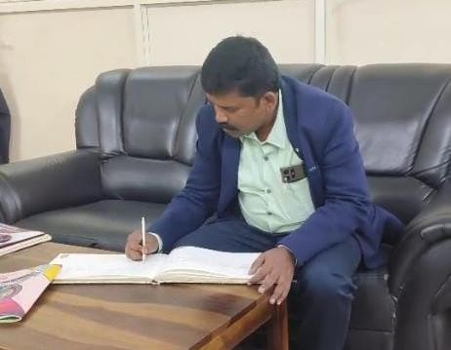
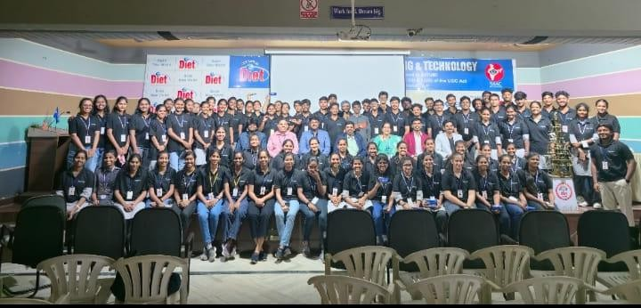

Mr. Omkar Amudala Mr. A Krishna Nag
Student Chair, DIET IEEE SB DIET IEEE SB Counselor

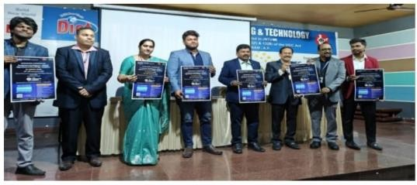
Anakapalle JL News January 24
The inaugural ceremony of the IEEE Computer Society Student Branch Chapter was held at Dadi Institute of Engineering and Technology (Autonomous) College under the auspicious of IEEE Student Branch. The program was inaugurated with the lighting of the lamp. The program was welcomed by IEEE Computer Society Chapter Advisor Dr. A. S. L. K. Gopalamma. The college principal Dr. R. Vaikuntha Rao said that the association with international organizations will increase the technical knowledge, research attitude and leadership qualities of the students. Akhil Kambeti, Data Engineer, IBM India Private Limited, spoke on the true value of data analysis. Dr. P. Shivakumar, Chair, IEEE Computer Society Vizag Section, participated as the chief guest and explained the benefits of IEEE membership. On this occasion, the IC PINAKA 2026 Conference Brochure was launched and a function was held to felicitate the guests. Finally, IEEE Student Branch Councillor Shri A. Krishna Nag proposed the vote of thanks.

Dadi Institute of Engineering and Technology Anakapalle Tomorrow morning, January 25: The inauguration ceremony of the IEEE Computer Society Student Branch Chapter was held grandly under the auspicious of the local Engineering and Technology (Autonomous) College. The program was inaugurated with the lighting of the lamp. The program was welcomed by I Triple E Computer Society Chapter Advisor Dr. A. S. L. K. Gopalamma. The college principal Dr.
R. Vaikuntha Rao said that the association with international organizations will increase the technical knowledge, research attitude and leadership qualities in the students. IBM India Private Limited Data Engineer Akhil Kambeti spoke on the true value of data analysis. IEEE Computer Society Vizag Section Chair Dr. P. Shivakumar participated as the chief guest and explained the benefits of IEEE membership. On this occasion, The IC--Pinaka 2026 conference brochure was launched and a guest felicitation program was organized. Finally, A. Krishna Nag, Student Branch Councillor of IEEE, proposed a vote of thanks.

